**Project 2: Write Into a Text File Using a Bot**

**Understanding The Problem Statement:**

**Problem Statement:** Our Aim is to create a bot which can open a text file available in the system and write a text into it and close the file successfully

**Solution Definition:**

1. We need to create a text file in the System.
2. Create a String variable and Assign Path of that Text File. (Action: ‘String: Assign’)
3. Open The Created File (Action: ‘Application: Open’)
4. To Write into the opened text file (Action: ‘Simulate Keystrokes’
5. Close the opened Text File (Action: ‘Window: Close’)

**Note:** The Process might change according to OS, as I am using Windows 11, automatic SAVE is available, but in OS like Window 7, when we click close button, it pops up a window requesting us to save, don’t save or cancel. In that Case, we need to use

Action: ‘Recorder: Capture’ to capture the save button and select Left Click TO complete Object setup.

**Procedure to Create the Bot:**

1. Login to your Control Room.

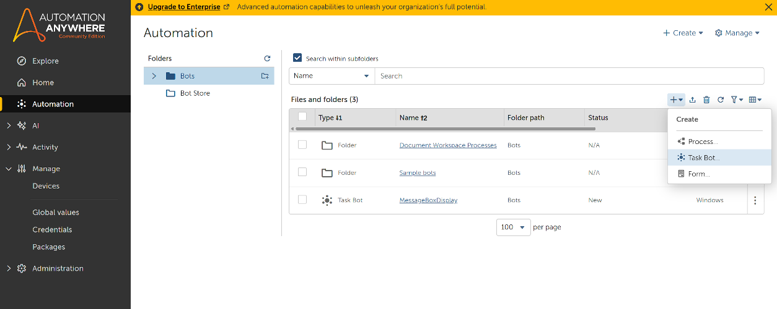

1. Click Automation in the Left Rail and click Create New Task Bot as Shown Above.

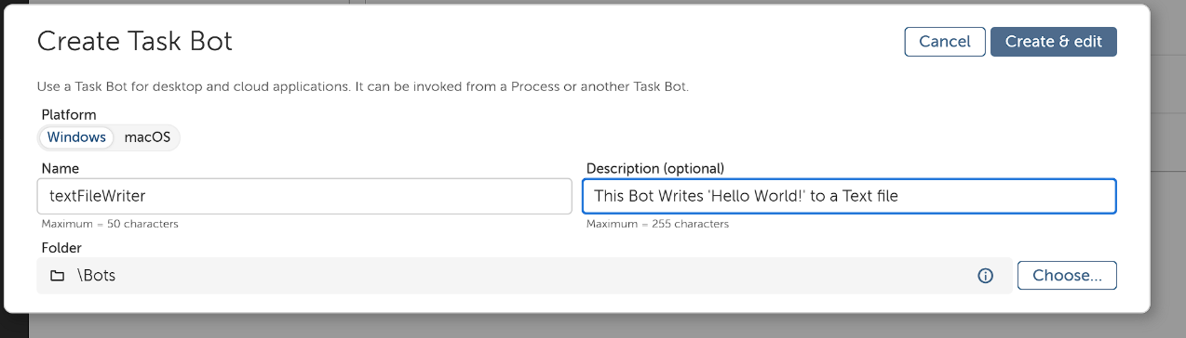

1. Enter the name of the bot and leave other options
2. Now you’ll be re-directed to Bot Action Panel.
3. Initialize a String Variable to assign System Path to it

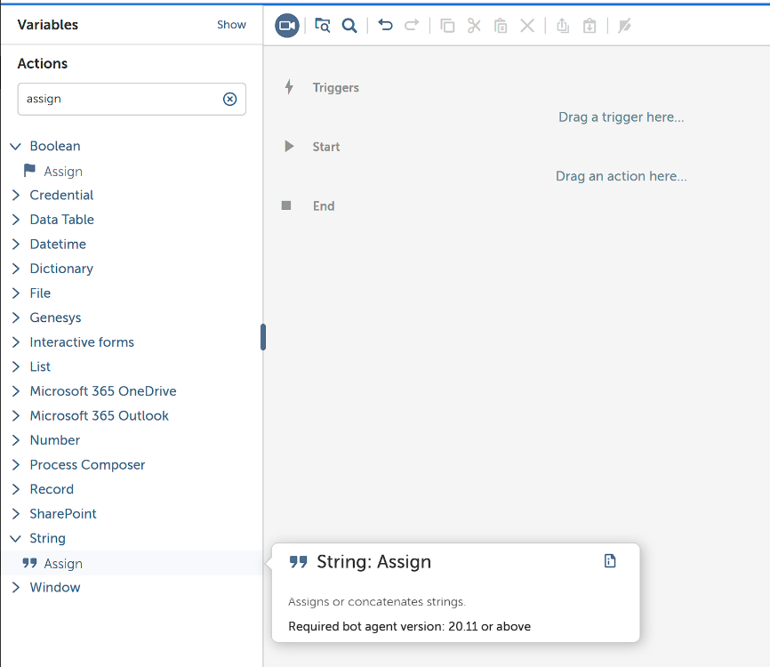

1. In actions, search for String: Assign and add it to Action Panel.

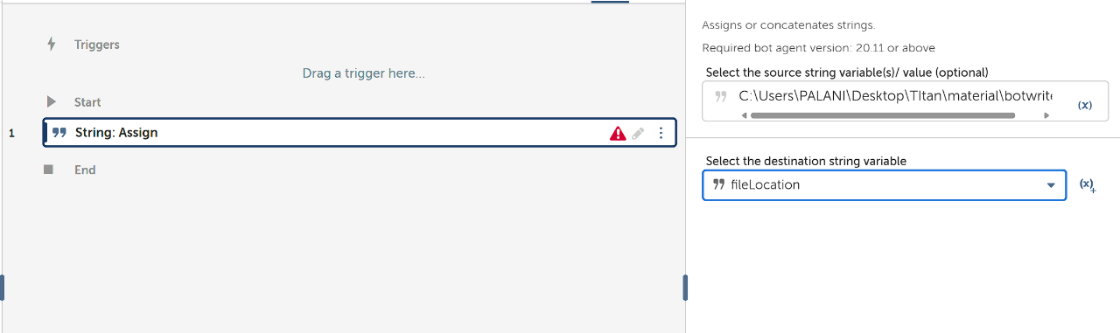

1. In the Right Side, Enter the System Path of the Created Text File and enter the name of string variable created earlier to store The System Path.

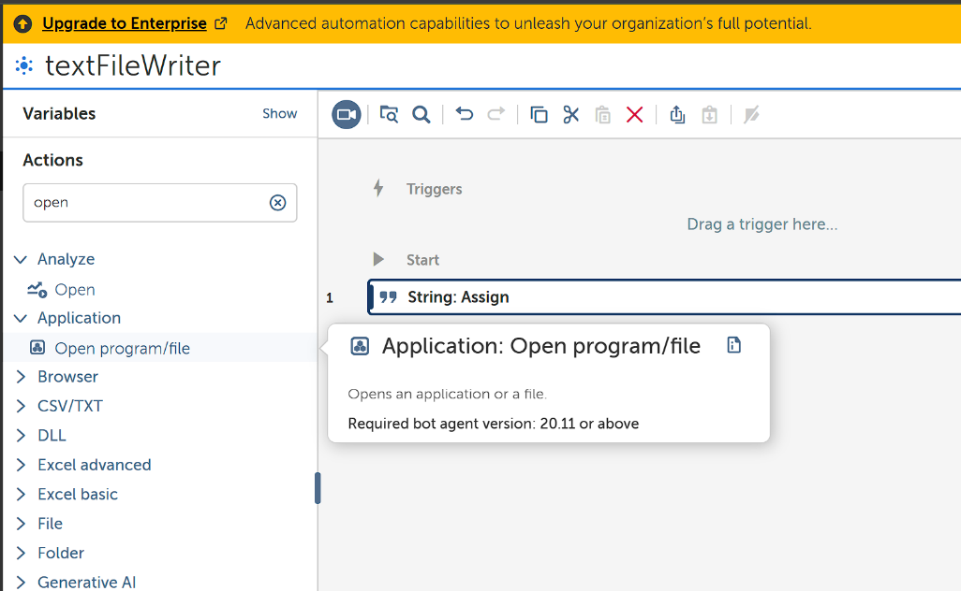

1. In Actions, search for Application: Open and Add it to Action Panel.

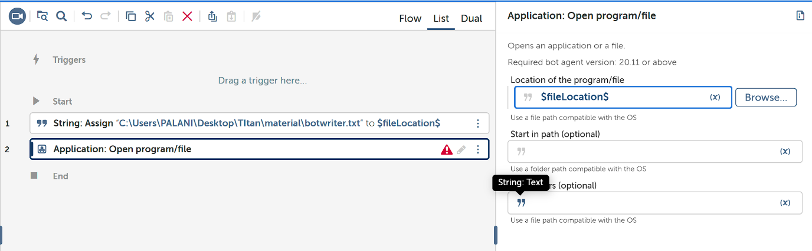

1. Now Insert the Location Variable, in Location of the program/file and leave others.

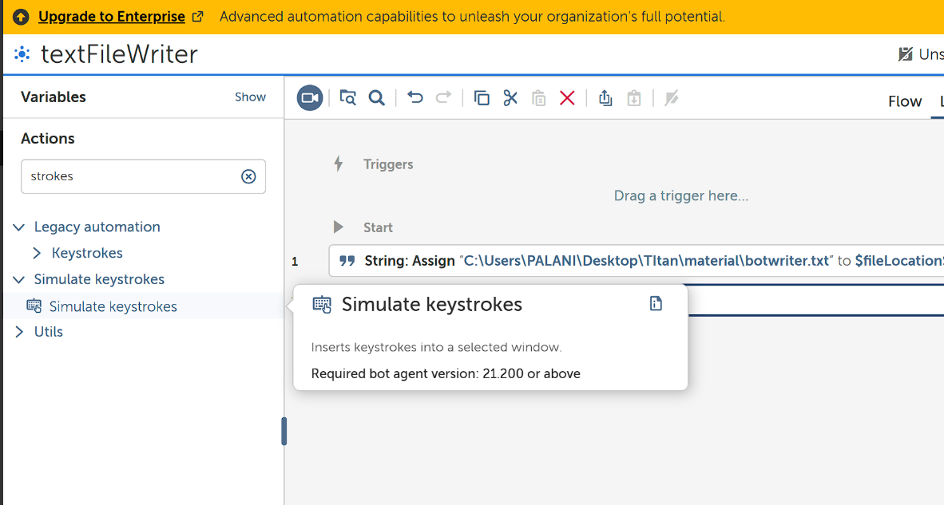

1. From Actions, Add Simulate Keystrokes to Action Panel.

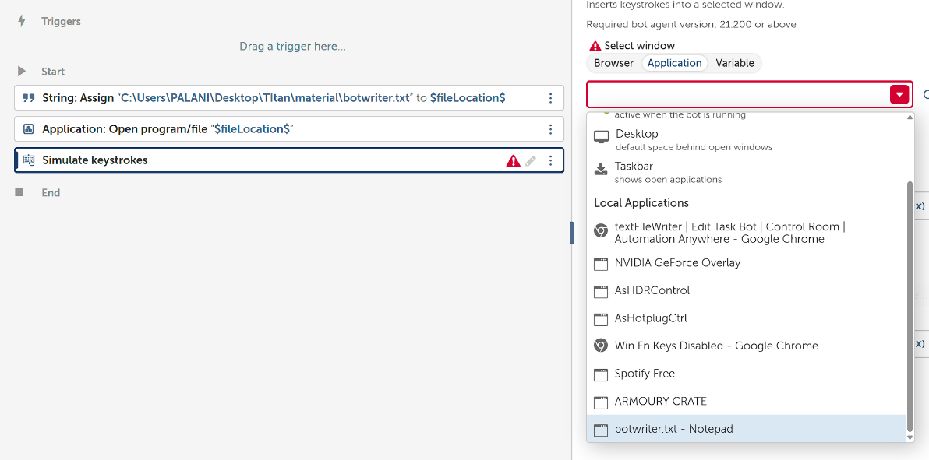

1. Make sure you had opened the Text file now and in Select Window >Application and the Select the Opened text file (Make Sure it is open, if not open the text file and refresh the search bar).

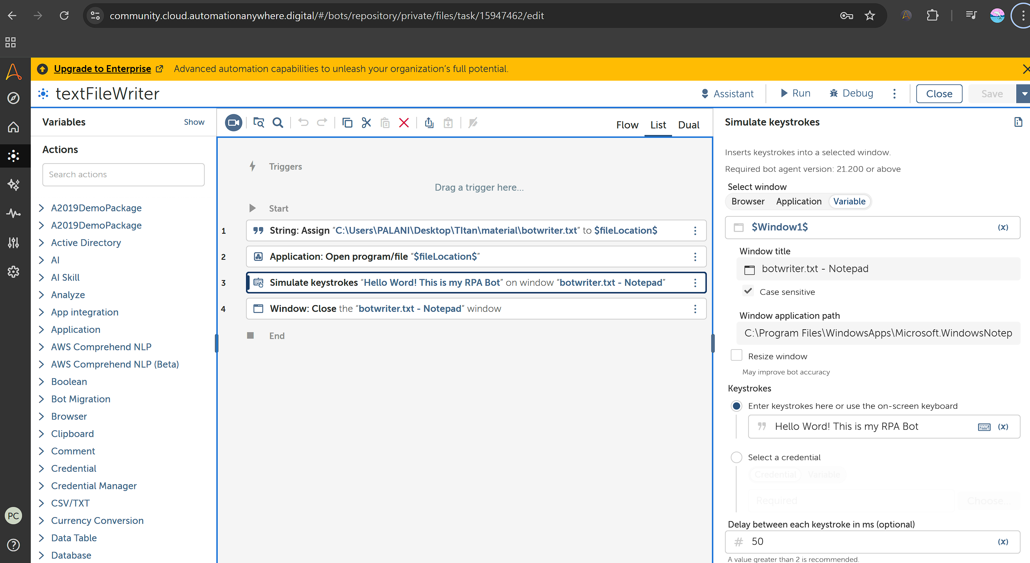

1. In key strokes available in the Action Details of Simulate Keystrokes action, Write the desired text to be written in it.

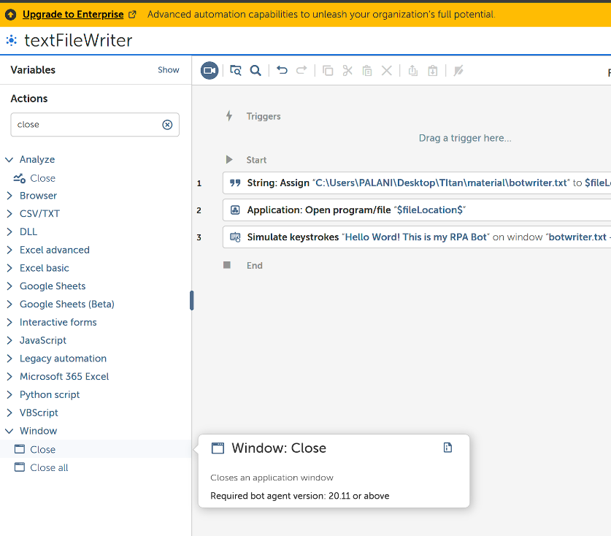

1. Add Window: Close from Actions to the Action Panel.

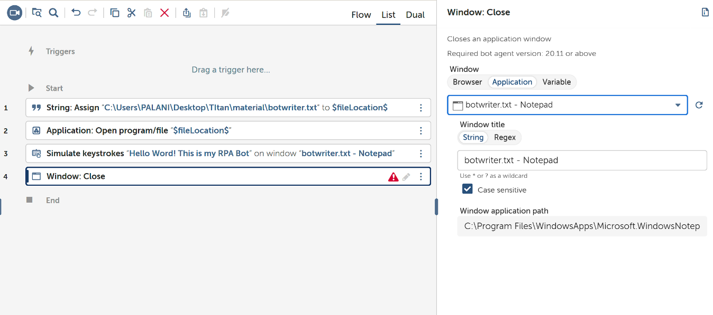

1. Select Which needs to Be closed, in our case we need to close the Text File which we kept open.
2. Now close the opened Text File (Make sure the file is Saved).
3. Run the Bot and You can see that the desired text is Written into the Text File. I have attached the video of Bot Running Successfully on my System.